**BELLABEAT CASE STUDY**

**INTRODUCTION**

**Company Profile:** Bellabeat

**Name:** Bellabeat Inc. **Founded:** 2013 **Founders:** Urška Sršen (Chief Creative Officer), Sando Mur **Headquarters:** San Francisco, California **Industry:** Health Tech / Wellness Technology **Target Market:** Women-focused health and wellness consumers **Website:** <https://bellabeat.com>

**Overview**

Bellabeat is a wellness technology company that designs elegant, data-driven smart products to help women better understand and manage their health. By combining advanced analytics with artistic design, Bellabeat offers a holistic approach to wellness tracking. The company has positioned itself as a leader in female-centric health tech, with a mission to empower women through smart technology.

**Products**

1. **Bellabeat App –** A central hub that tracks activity, sleep, stress, hydration, menstrual cycles, and mindfulness practices.
2. **Leaf –** A wearable wellness tracker in the form of a bracelet, necklace, or clip, focused on activity, sleep, and stress.
3. **Time –** A hybrid smartwatch with classic design and wellness features like sleep, stress, and activity tracking.
4. **Spring –** A smart water bottle that monitors hydration and syncs with the Bellabeat app.
5. **Bellabeat Membership –** A subscription-based platform offering personalized coaching on lifestyle, health, and wellness.

**Technology & Data Use**

Bellabeat integrates smart device data with analytics to generate personalized insights for users. The company gathers data on:

* Physical activity
* Sleep patterns
* Stress levels
* Hydration
* Reproductive health

This data helps users make informed health decisions while enabling Bellabeat to enhance its marketing and product strategies.

**PREPARE**

**Business Task**

To conduct a comprehensive analysis of publicly available smart fitness device data—specifically, Fitbit user data—in order to:

1. Identify Usage Trends

Understand user behavior patterns related to physical activity, sleep, and overall wellness from the Fitbit dataset.

1. Generate Consumer Insights

Derive insights that reflect how consumers typically engage with wellness technology products, including frequency, duration, and type of usage.

1. Strategically Apply Findings to Bellabeat’s Offerings

Select one Bellabeat product (e.g., Leaf, Time, Spring, or Bellabeat App) and apply the findings to:

* Enhance product positioning
* Improve customer engagement
* Inform digital marketing campaigns

**Dataset Overview: Fitbit Fitness Tracker Data**

As part of the Bellabeat case study, I analysed a publicly available dataset that captures detailed activity and health-related information from Fitbit users. This dataset serves as a **proxy for understanding broader smart device usage trends**, which can then be applied to improve Bellabeat’s product strategy and marketing efforts.

**Dataset Source**

* **Name:** [Fitbit Fitness Tracker Data](https://www.kaggle.com/datasets/arashnic/fitbit)
* **Published on:** Kaggle
* **License:** Public Domain (CC0)
* **Submitted by:** Mobius
* **Access:** Open and free to use for educational and analytical purposes

**Dataset Description**

* **Participants:** Data collected from **35 Fitbit users** who consented to share their anonymized personal fitness data.
* **Data Granularity:** Includes **minute-level, daily, and hourly data**.
* **Key Variables Tracked:**
  + **Physical Activity:** Steps taken, calories burned, distance covered, intensity levels
  + **Heart Rate:** Resting and active heart rate readings
  + **Sleep:** Duration, efficiency, and sleep stage information
  + **Weight Tracking:** Weight, BMI, and body fat percentage (for some users)

**Files Included**

The dataset contains multiple CSV files, including:

* dailyActivity_merged.csv
* sleepDay_merged.csv
* heartrate_seconds_merged.csv
* weightLogInfo_merged.csv
* minuteCaloriesNarrow_merged.csv
* Others covering daily intensities, step counts, and calories

**ROCCC Analysis**

| **Criteria** | **Assessment** |
| --- | --- |
| **Reliable** | Data is generated from Fitbit devices, ensuring consistency, but limited to 30 users, reducing statistical reliability. |
| **Original** | Publicly available secondary data sourced from Kaggle, not collected by Bellabeat. |
| **Comprehensive** | Includes rich behavioral data (steps, sleep, heart rate), but lacks demographic and contextual details. |
| **Current** | Data is from 2016, which may not reflect current device usage or consumer trends. |
| **Cited** | Properly cited and licensed (CC0), though data collection methodology is not fully documented. |

**DATA CLEANING PROCESS**

For this project, I followed a two-step data cleaning approach using Microsoft Excel and SQL to prepare the Fitbit dataset for analysis.

**Initial Cleaning in Excel**

The raw CSV files were first loaded into Excel for basic preprocessing tasks:-

* **Duplicate Removal:** Identified and eliminated duplicate entries to ensure data integrity.
* **Date Formatting:** Standardized inconsistent date formats across all files to support accurate time-based analysis.
* **Missing Values:** Performed initial checks for null or missing values and removed or corrected them as necessary.

**Data Structuring in SQL**

After basic cleaning, the refined dataset was imported into a SQL database for further processing and analysis:

* **Aggregation Functions:** Used functions such as AVG() to calculate average values across key metrics (e.g., steps, sleep duration).
* **Weekday Analysis:** Extracted day-of-week from timestamp data to analyse behavioural trends across different weekdays.
* **Grouping and Summarization:** Utilized the GROUP BY clause to summarize user activity by date, user ID, and day of the week for more granular insights.

[**TABLEU DASHBOARD**](https://public.tableau.com/authoring/FitBitDataAnalysis-DailyandWeeklyBellabeatCaseStudy/Dashboard1#1)

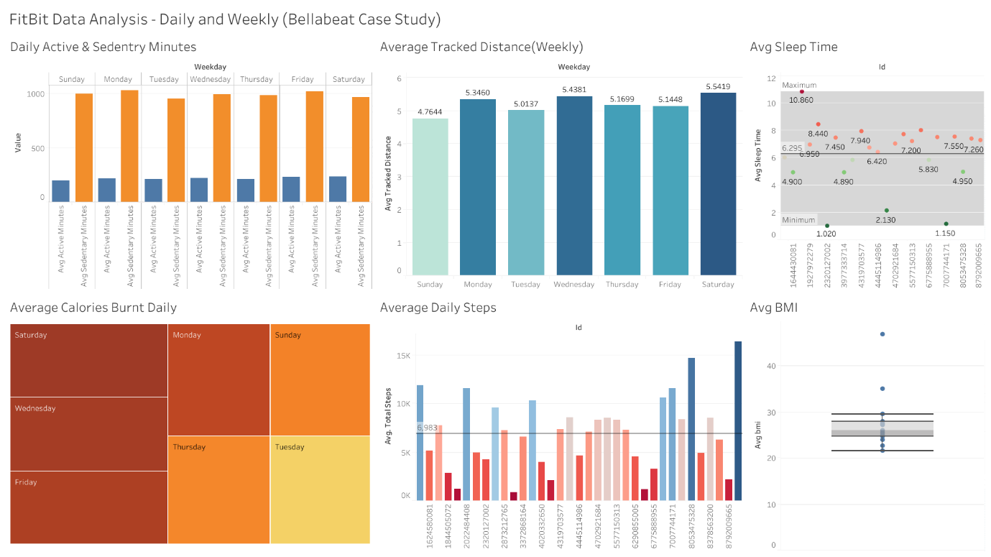

**OBSERVATIONS**

**1. Sedentary Lifestyle Patterns**

Across all weekdays, users spend significantly more time being sedentary than active. This pattern suggests a largely inactive user base despite wearing fitness trackers. Bellabeat can address this by integrating features into its app that encourage movement throughout the day—such as hourly movement reminders, short activity prompts, or personalized micro-goals. These interventions can help users gradually shift toward a more active routine without requiring major behavioural changes.

**2. Weekly Activity Peaks: Distance and Calories**

The highest average tracked distances occur on Wednesday and Saturday, while calorie expenditure also peaks on these days (along with Friday). This indicates that users are most active mid-week and on weekends. Bellabeat can use this insight to schedule fitness challenges and promotional content around these days. For example, a “Wellness Wednesday” campaign or “Weekend Burn” challenge could capitalize on users’ existing motivation and further boost engagement.

**3. Inconsistent Sleep Patterns**

The sleep data reveals considerable variation, with most users averaging 6–8 hours of sleep, but some logging as little as 1–2 hours. These inconsistencies suggest stress or poor sleep hygiene. Bellabeat’s app can play a critical role by offering sleep analytics, bedtime reminders, and guided meditations. Emphasizing the app’s stress management features can also help users adopt better nighttime routines and improve overall health.

**4. Uneven Step Counts Across Users**

The average daily steps chart shows wide discrepancies among users—while some surpass 10,000 steps per day, many fall well below. This gap suggests varying levels of engagement or fitness. Bellabeat should introduce personalized goal-setting, progressive step targets, and milestone rewards to motivate users across all fitness levels. Encouraging gradual improvement rather than only high performance will promote consistency and reduce drop-off rates.

**5. BMI Distribution and Health Risk Indicators**

Most users fall within the normal to overweight BMI range, but a few show significantly high values (>40), signaling potential health risks. Bellabeat can use this information to offer tailored lifestyle recommendations focused on weight management. Products like the Bellabeat App and Spring smart water bottle can support habit formation in hydration, movement, and sleep—core factors influencing BMI.

**Strategic Opportunities for Bellabeat**

**Product Positioning**

Position Bellabeat not just as a fitness tracker, but as a holistic wellness platform. Highlight its ability to support users across key health dimensions: activity, sleep, stress, and hydration.

**Customer Engagement**

Leverage behavioural data to create intelligent engagement strategies:

* Launch activity-based campaigns aligned with high-activity days.
* Offer personalized nudges based on sleep and step tracking.
* Introduce milestone rewards to sustain motivation.

**Digital Marketing**

Segment marketing campaigns by behavioural patterns:

* Promote fitness features to low-step or sedentary users.
* Advertise sleep and stress features to users with erratic sleep data.
* Use success stories and testimonials to demonstrate health improvements across different user types.